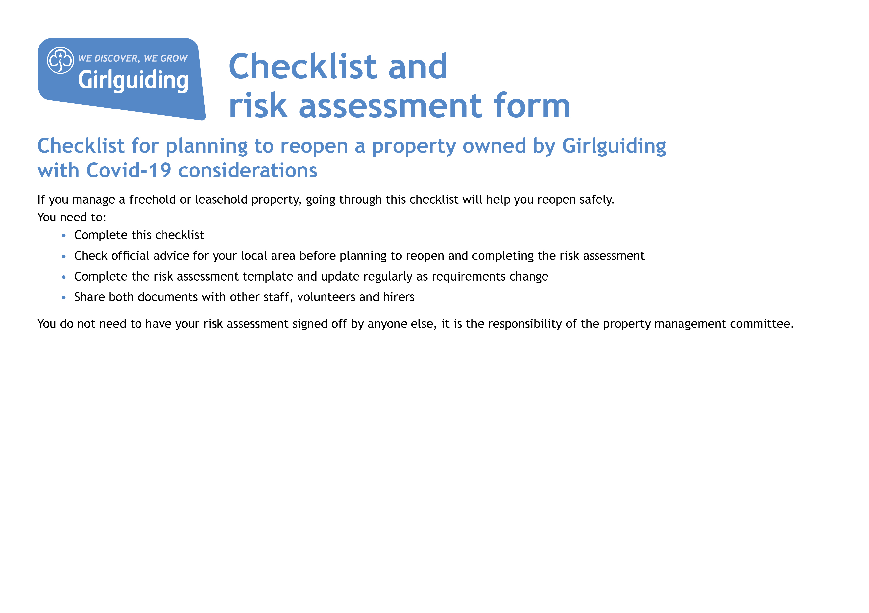

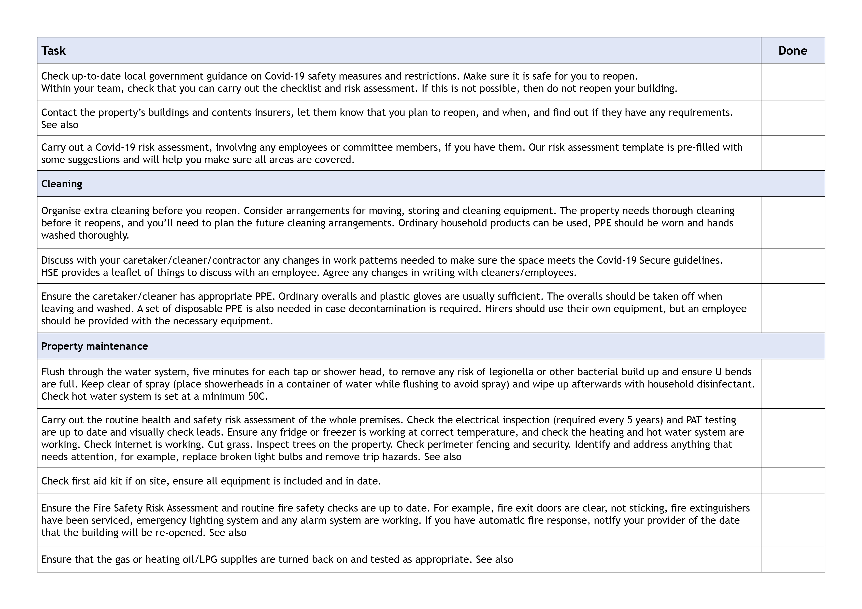

YES
YES
YES
YES
YES
YES
YES
YES
YES
YES
Be prepared: health and safety
Fire Risk Assessment pdf
Be prepared: health and safety
Insurance issues for property managers

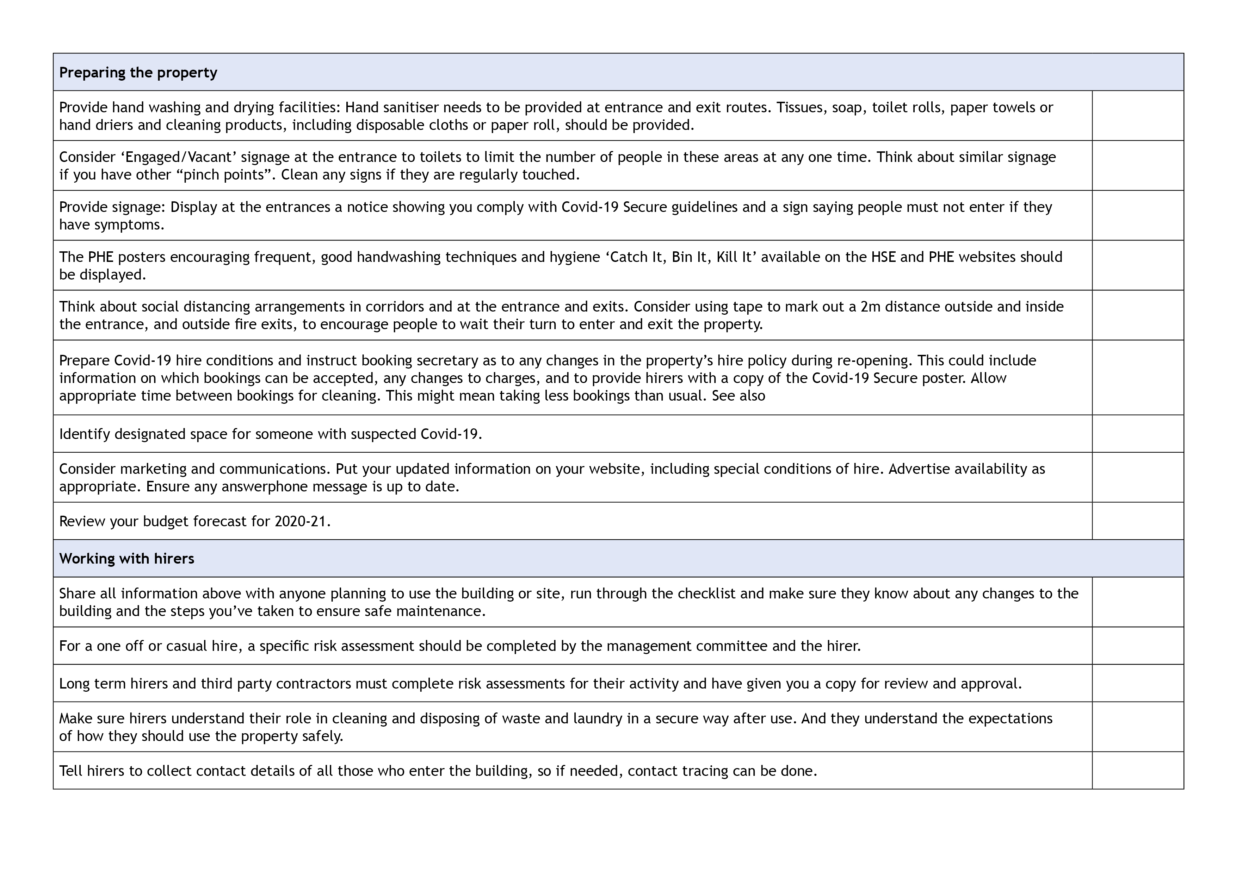
YES
YES
YES
YES
YES
YES
YES
YES
YES
YES
YES
YES
YES
YES
Hiring out your hall

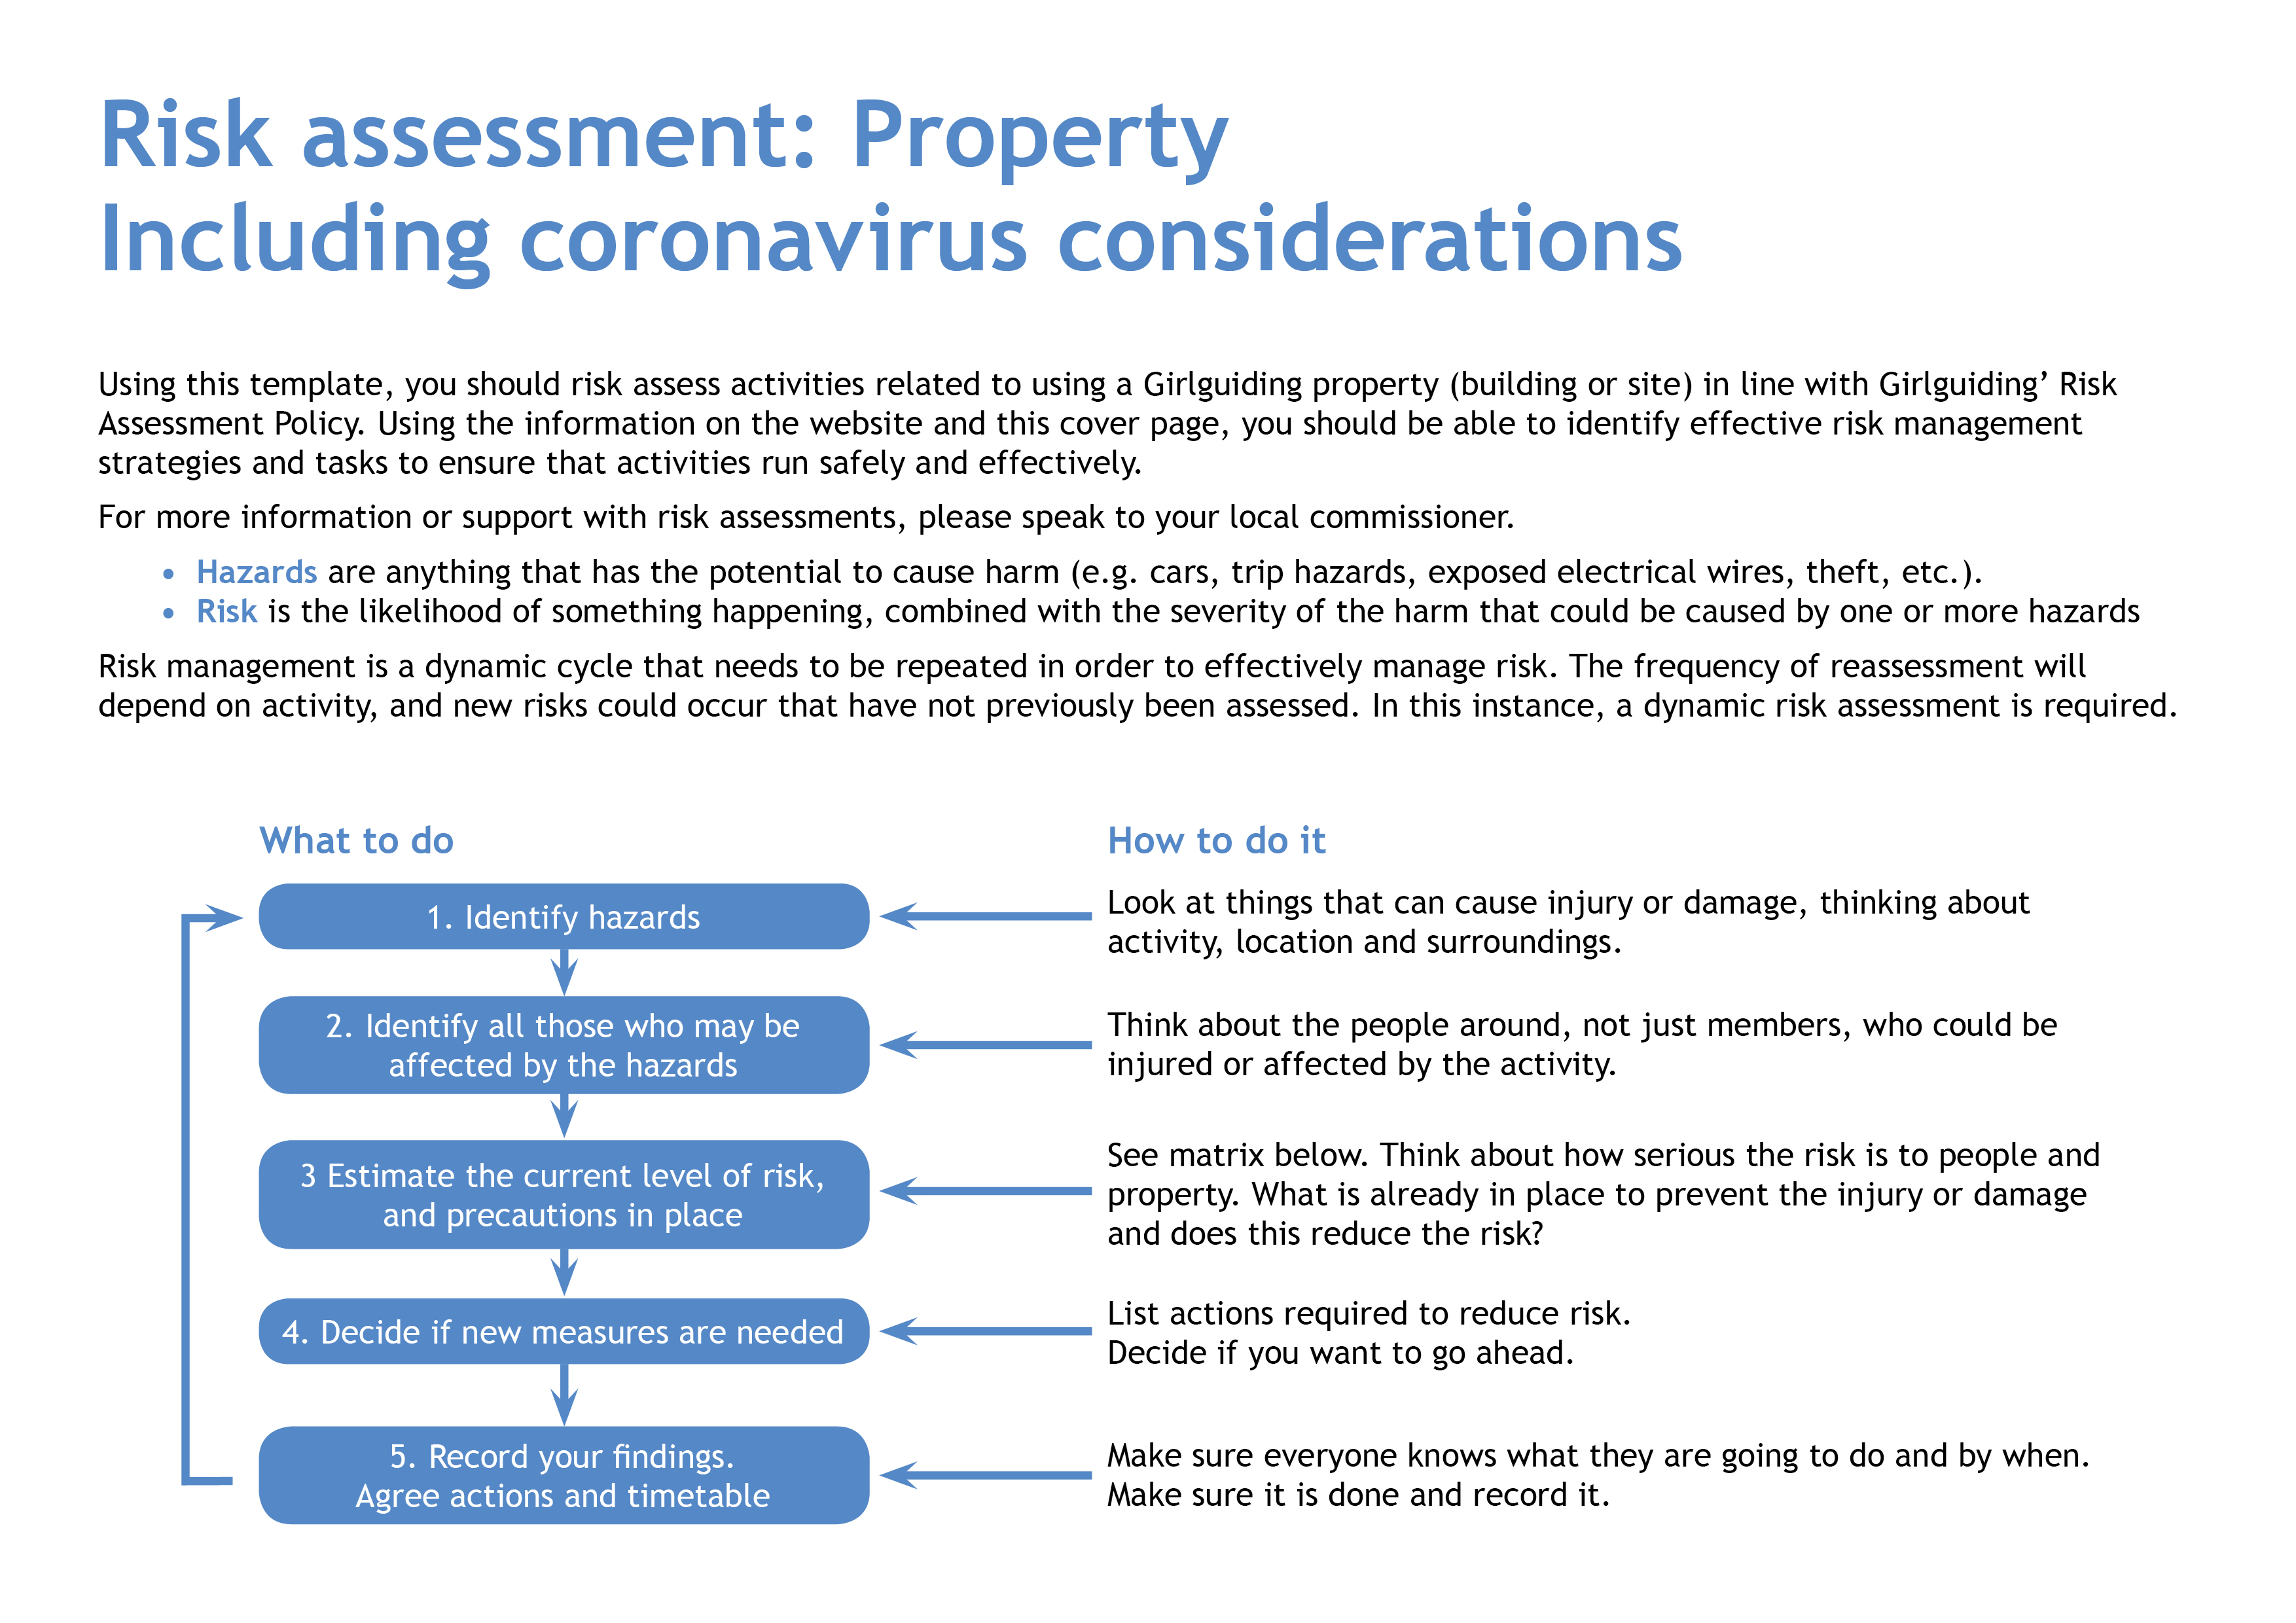

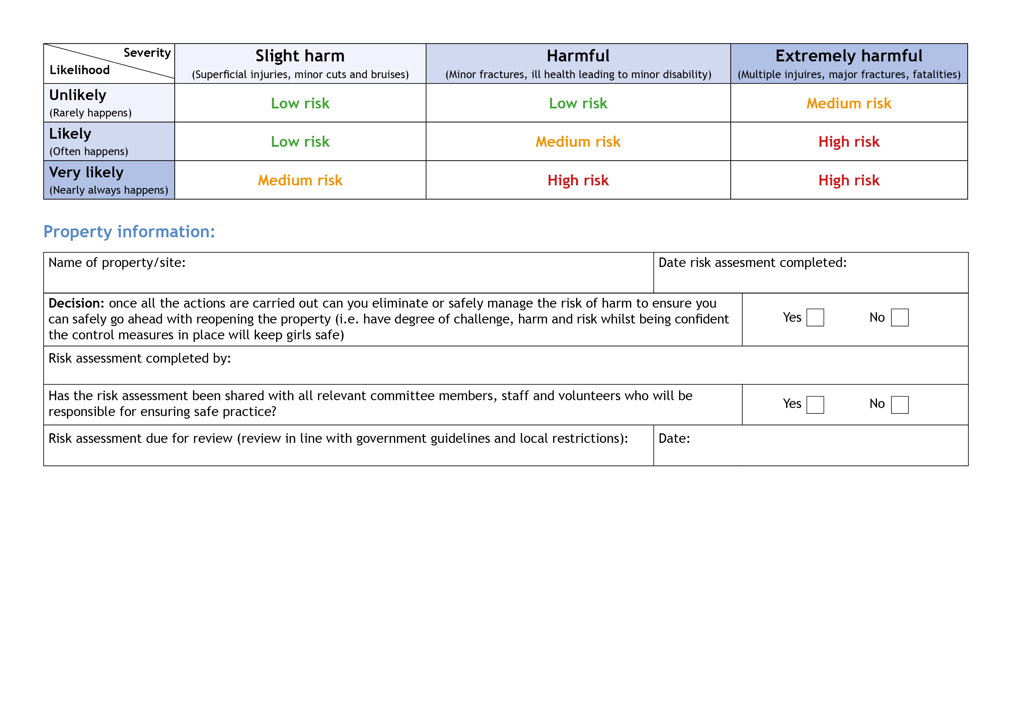
01/01/2021 OR EARLIER DEPENDANT ON GOVT POLICY
X

X

KAREN BINNS COUNTY COMMISSIONER
31/08/2020
NORTHERN HEIGHTS
Hazards  What could cause harm or damage? | Who or what is at risk of being affected and how? | What are you already doing?  How have you reduced the risk already? | Likelihood of risk occurring  (L/M/H) | Severity of risk  (L/M/H) | Are further controls necessary?  What else needs to happen to reduce the risk to an acceptable level? | Action by:  name/date
Long term closure means that systems may not have been working for an extended period.  This could mean that statutory compliance has not been maintained. | All users – may become ill or be  put at greater risk because systems  are not working correctly. | Make sure that all systems are re-commissioned before any meetings take place.  This must include checks for fire and water systems and gas safety. Checks should also be performed on heating and ventilation systems and emergency lighting.  Perform deep clean prior  to opening.  Complete checklist for reopening. | Medium | High | Consider employing specialists to carry out checks if not confident to do yourselves. Follow checklist to ensure that all relevant tests are carried out. | DIRECT ECO SOLUTIONS WEEK OF 24/08/2020
Coronavirus infection risks below are in consideration of this risk and reducing it to an acceptable level. | All people using the facility from spread of virus through close contact. |  | Low | High
Staff, volunteers,  contractors and users. | All could be at risk of exposure to virus through their roles, likely to include those carrying out cleaning, caretaking or maintenance. | Discuss the situation with staff/volunteers in high risk groups to identify whether provision of protective clothing and cleaning surfaces is sufficient to mitigate their risks, or whether they should cease such work or volunteering for the time being. |  |  | Request RA and procedure for Covid-19 from contractors and users and review them.  Staff training/ regular briefing  of users.  PPE provision for staff/volunteers.  Respirator, aprons, goggles, face masks added to site PPE and first aid kits  Cleaning regimes, all contact surfaces to be regularly cleaned.  Doors on automatic release to keep open on regular walk ways. Fire evacuation procedure to be updated if you have doors open to ensure doors closed when not  in use. | KB,AN,DM  24/08/2020

Hazards  What could cause harm or damage? | Who or what is at risk of being affected and how? | What are you already doing?  How have you reduced the risk already? | Likelihood of risk occurring  (L/M/H) | Severity of risk  (L/M/H) | Are further controls necessary?  What else needs to happen to reduce the risk to an acceptable level? | Action by:  name/date
All areas. | Potential for cross contamination and passing infection, between users. | Set out a procedure on what cleaning is required and how regularly this should be done for each hirer, include  door handles, light switches, window catches, tables, chairs and other equipment used to be cleaned by hirers before use or by property cleaning staff. | LOW | LOW | Detail chemical to be used for cleaning. Something with a bleach product – COSHH risk assessment required on product (assessment of working with hazardous materials).  ENDO-SAR PROVIDED BY DIRECT ECO SOLUTIONS | KB, AN, DM
Entrance halls/lobby,  in corridors. | Capacity for social distancing is reduced thereby increasing the risk to all users. | Check the number of users meeting at the venue at the same time.  Work with hirers to plan the numbers that can be accommodated.  Provide hand sanitiser at  all entrances.  Put a one-way system in place if necessary – use one door for entrance and one for exit.  Provide signage. |  |  | Reorganise booking times or change days and time in order to maximise capacity for all users and allow for cleaning in between.  Hand sanitiser needs to be  checked daily.  Provide more bins, in entrance hall, each meeting room.  Empty regularly.  All bought and in place. | DM, CM

Hazards  What could cause harm or damage? | Who or what is at risk of being affected and how? | What are you already doing?  How have you reduced the risk already? | Likelihood of risk occurring  (L/M/H) | Severity  of risk  (L/M/H) | Are further controls necessary?  What else needs to happen to reduce the risk to an acceptable level? | Action by:  name/date
Car parks/paths/patios/  exterior areas. | Start and end of meetings creates risk of breaching social distancing guidelines for property users and those dropping off or picking  up users. | Have a drop off and pick up process that is communicated to all users  in advance.  Mark out two metre waiting area outside all potential entrances with tape to encourage care when queuing to enter. If space does not allow this state that masks must be worn.  Keep all external areas clear of contaminated rubbish. | LOW | MED | Encourage those picking up and dropping off from cars to remain  in their cars.  Suggest to hirers that they limit drop off and pick up to one parent/carer/adult.  Consider staggered start and finish times for bookings.  Make sure that there is a 15 minute gap between hirers to ensure there can be no cross over between groups. | KB,AN,DM, CM
Main hall/meeting space. | Capacity for social distancing is reduced thereby increasing the risk to all users. | Set a limit on numbers attending – check relevant government guidance for your local area. (15 PLUS ADULTS)  Remove unnecessary items from the hall/space.  Social distance guidance to be observed by hirers in arranging their activities.  Remove soft furnishings and things that are hard to clean from venue. | MED | MED
Small meeting rooms  and offices. | Capacity for  social distancing is reduced thereby increasing the risk  to all users. | Don’t use these rooms if social distancing cannot be observed. If use is required make sure that masks are worn if social distancing cannot be observed.  Have a one in one out system.

Hazards  What could cause harm or damage? | Who or what is at risk of being affected and how? | What are you already doing?  How have you reduced the risk already? | Likelihood of risk occurring  (L/M/H) | Severity  of risk  (L/M/H) | Are further controls necessary?  What else needs to happen to reduce the risk to an acceptable level? | Action by:  name/date
Kitchen. | Capacity for social distancing is reduced thereby increasing the risk to all users. | Ask hirers to control the numbers using the kitchen area so as to ensure social distancing.  Hirers to clean all areas likely to be used before use, wash, dry and stow crockery and cutlery after use.  Hirers to bring own tea towels.  Hand sanitiser to be provided.  Hirers to be encouraged to bring their own food and drink. |  |  | Cleaning materials to be made available in clearly identified location, eg a box on one of the kitchen surfaces, regularly checked and re-stocked as necessary.  Consider closing kitchen if not required or restricting access.  Disposable crockery (paper plates) and plastic/wood cutlery. | AN, DM, CM
Use of shared resources. | Leads to risk of increased transmission. | Do not allow different user groups to use the same resources unless you can make sure that there is a clear protocol in place for cleaning and quarantining resources before using  them again.  Consider types of activities that are appropriate and inform users of cleaning arrangements for resources ahead of use so that they can include in their risk assessment.  Ensure thorough cleaning between different groups if areas and resources  are shared. |  |  | Ask users to bring their own equipment.

Hazards  What could cause harm or damage? | Who or what is at risk of being affected and how? | What are you already doing?  How have you reduced the risk already? | Likelihood of risk occurring  (L/M/H) | Severity  of risk  (L/M/H) | Are further controls necessary?  What else needs to happen to reduce the risk to an acceptable level? | Action by:  name/date
Toilets. | Social distancing difficult. | Hirer to control access to toilets with particular attention to more  vulnerable users.  Hirer to clean all surfaces etc (basins, baby changing and other surfaces, toilet pans/seats) after use. |  |  | Ensure soap, paper towels, tissues and toilet paper are regularly replenished and hirer knows where to access for  re-stocking if needed.  Assign specific toilet facilities to individual groups visiting the site to encourage distancing and limit access.  Toilet facilities to be cleaned between user groups. | DM
Poor respiratory or handwashing hygiene on the part of meeting attendees. | Risk of increased transmission. | Ensure clear signage that reinforces cleaning and hygiene routine in line with Covid-19 Secure guidelines:  Minimise contact with individuals who are unwell.  Clean your hands often.  Avoid touching mouth, eyes and nose. Dispose of tissues in a bin. Display catch it,  kill it, bin it poster.  Ensure regular cleaning of surfaces that are touched frequently.  Maintain social distance  where possible.  Make sure that where possible windows and doors are unlocked for users to open them during a meeting (remember to remind users not to prop open fire doors and be mindful of safeguarding considerations). |  |  | Display relevant posters.  Large supply of posters and spares ready for display  Detailed covid operating procedures to identify how hygiene and social distancing will be maintained across the site by all users during visits. These will be shared with staff and volunteers and relevant sections communicated with site visitors.

Hazards  What could cause harm or damage? | Who or what is at risk of being affected and how? | What are you already doing?  How have you reduced the risk already? | Likelihood of risk occurring  (L/M/H) | Severity  of risk  (L/M/H) | Are further controls necessary?  What else needs to happen to reduce the risk to an acceptable level? | Action by:  name/date
Someone becomes ill during the course of  a meeting. |  | Set up a designated safe area that should be used if someone becomes ill.  Have a clear guidance on who users should inform and what they should do.  Make sure that appropriate and relevant cleaning arrangements can  be implemented.  The individual (or parent) will notify Karen Binns County commissioner countycommissioner@ggme.co.uk and Northern Heights chair Alison Nugent  Alisonmnugent@gmail.com |  |  | Have a supply of PPE in on site  first aid kit, including gloves, disposal aprons, face coverings.  Designated area for symptomatic persons: Blackthorn patio  Add to covid terms and conditions the requirement for hirers to retain attendance information for track and trace purposes and notify the site of any suspected or confirmed covid cases during or following a visit.
Property users do not adhere to guidelines. | All | Share the property risk assessment with the hirers  in advance.  Hirer to confirm that an appropriate risk assessment for the group/activity that is meeting at the venue has been completed.  Long term hirers and third party contractors must share these with you.  Make sure relevant information about contact tracing procedures has been included and that no one attends if they show any signs of being unwell. |  |  | Put in place any Covid-19 secure conditions that can be added to the booking process (and clearly communicated to new and existing bookings) – this could include clear instructions about cleaning responsibilities, maintaining social distancing, maximum attendance numbers, disposal  of rubbish and appropriate activities.  Carry out a risk assessment with one off or casual hirers.

Hazards  What could cause harm or damage? | Who or what is at risk of being affected and how? | What are you already doing?  How have you reduced the risk already? | Likelihood of risk occurring  (L/M/H) | Severity  of risk  (L/M/H) | Are further controls necessary?  What else needs to happen to reduce the risk to an acceptable level? | Action by:  name/date
Reputation of Girlguiding Middlesex East and Northern Heights | GG Middlesex East and NH being seen by members of the public or HQ not following current UK Government guidelines and Girlguiding policies regarding COVID 19 | The site warden, site volunteers and visitors briefed regarding standards to adhere to whilst at Northern Heights. |  |  | Additional signage around the site reminding people of the rules/requirements  Share instructions and risk assessment with staff and volunteers before visits and regularly / as changes are made.  Covid-19 page of website and all bookings directed to this with Covid specific terms, confirmation fo acceptance within booking process and briefed on arrival. | KB, AN, DM

